📘 PROJECT DOCUMENTATION
Project: Location-First AI Navigation System (Leaflet + OSRM)
File Type: Single-page Web Application (HTML + CSS + JavaScript)
Purpose: Real-time GPS navigation with AI driving assistance, voice guidance, rerouting, eco-tips, and Google-Maps-style UX.

1️⃣ HIGH-LEVEL SYSTEM OVERVIEW
This system is a client-side navigation engine that:
• Tracks real-time user GPS
• Displays a rotating, compass-based map
• Builds routes using OSRM (Open Source Routing Machine)
• Generates step-by-step navigation instructions
• Monitors driver behavior (speed, route deviation)
• Gives AI-based eco driving suggestions
• Automatically reroutes if driver goes off-route
• Supports manual map selection, search, and voice input

2️⃣ CORE ARCHITECTURE (HOW EVERYTHING CONNECTS)
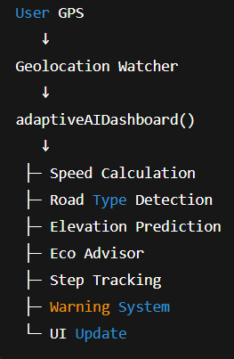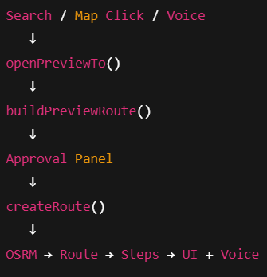

3️⃣ MAIN SYSTEM STATES
State | Description
Idle | User moving without navigation
Preview | Destination selected but not started
Navigation | Active route guidance
Rerouting | Off-route detected
Arrival | Destination reached

4️⃣ GLOBAL VARIABLES (SYSTEM MEMORY)
Navigation State:
Variable | Purpose
routes[] | Stores all active routes
activeRouteIndex | Which route is currently followed
currentStepIndex | Current navigation instruction
waypoints[] | Ordered navigation points
waypointMarkers[] | Map markers for waypoints

GPS / Motion:
Variable | Purpose
userMarker | Vehicle position on map
lastHeading | Direction of movement
useVirtualGPS | Simulated GPS fallback
AI / Speech:
Variable | Purpose
SPEECH | Speech state, cooldowns, memory
announcedSteps | Prevents repeat announcements

5️⃣ FUNCTION-BY-FUNCTION DOCUMENTATION

🔹 safeFetch(url, retries):
Purpose
Controls API calls safely by queuing requests and preventing overload.
Inputs
• url → API endpoint
• retries → Retry count
Source of Inputs
Called by routing, elevation, and search systems.
Outputs
• Returns a resolved fetch() response
• Or rejects on failure
Used By
• OSRM routing
• Elevation API
• Search APIs

🔹 processQueue() :
Purpose
Executes queued API calls one-by-one with rate limiting.
Inputs
None (uses global request queue)
Outputs
• API responses processed safely
Used By
• safeFetch()

🔹 aiBoxShow(kind, text) :
Purpose
Updates the AI tip banner at the top of the UI.
Inputs
• kind → eco / step / warning
• text → Message to show
Outputs
• Updates DOM element #ai-tip
Used By
• Speech system
• Eco advisor
• Step announcements

🔹 speak(text, kind, options) :
Purpose
Plays voice instructions using Web Speech API.
Inputs
• text → Speech content
• kind → eco / step / warning
• options.interrupt → Cancel previous speech
Outputs
• Audible voice output
• Updates speech memory
Used By
• Navigation steps
• Speed warnings
• Eco tips

🔹 buildPreviewRoute(startLL, endLL, label) :
Purpose
Creates a temporary route preview before navigation starts.
Inputs
• startLL → Starting LatLng
• endLL → Destination LatLng
• label → Destination name
Outputs
• Blue preview polyline
• Distance & duration shown in approval panel
Used By
• Search selection
• Map click selection

🔹 openPreviewTo(latlng, label, addMarker)
Purpose
Handles destination selection & confirmation workflow.
Inputs
• latlng → Selected point
• label → Name
• addMarker → Boolean
Outputs
• Popup marker
• Voice confirmation
• Preview route created
Used By
• Search results
• Map click
• Voice search

🔹 createRoute(start, end, color, marker) :
Purpose
Creates a final navigable route using OSRM.
Inputs
• start → Start point
• end → End point
• color → Route color
• marker → Destination marker
Outputs
• OSRM route control
• Step list UI
• Step polylines
• Voice instruction
Used By
• Approval panel
• GM route panel

🔹 adaptiveAIDashboard(latlng, heading) :
Purpose
Central AI brain that updates everything every second.
Inputs
• latlng → Current position
• heading → Movement direction
Outputs
• Speed UI
• Gear UI
• Throttle UI
• Eco advice
• Warnings
• Step tracking
Used By
• GPS watcher
• Virtual GPS

🔹 calculateGPSSpeed(latlng) :
Purpose
Calculates speed based on GPS movement.
Inputs
• latlng → Current position
Outputs
• Speed in km/h
Used By
• Eco advisor
• Speed warnings
• Road type detection

🔹 ecoAdvisor(distance, slope) :
Purpose
Generates eco-driving recommendations.
Inputs
• distance → Lookahead distance
• slope → Road gradient
Outputs
• Recommended speed
• Gear
• Throttle
• Tip text
Used By
• AI dashboard
• Voice system

🔹 predictElevationAhead(latlng, heading) :
Purpose
Predicts upcoming slope using Open-Elevation API.
Inputs
• latlng
• heading
Outputs
• Elevation array
• Average slope
Used By
• Eco advisor

🔹 smartStepAdvancement(latlng)
Purpose
Detects which navigation step the driver is actually on.
Inputs
• latlng
Outputs
• Updates current step
• Skips missed steps
• Announces correct instruction
Used By
• AI dashboard

🔹 checkUpcomingSteps(latlng) :
Purpose
Announces upcoming turns in advance.
Inputs
• latlng
Outputs
• Voice instruction when within range
Used By
• Navigation loop

🔹 safeReroute(route, currentLL) :
Purpose
Recalculates route when driver goes off-path.
Inputs
• route → Active route object
• currentLL → Current position
Outputs
• New route
• Reset steps
• Voice announcement
Used By
• Off-route detection logic

🔹 getSearchResults(query) :
Purpose
Next-gen search engine (Photon + Nominatim + Wikipedia).
Inputs
• query → User text
Outputs
• Ranked location results
Used By
• Search bar
• GM route panel

6️⃣ COMPLETE WORKFLOW (END-TO-END) :
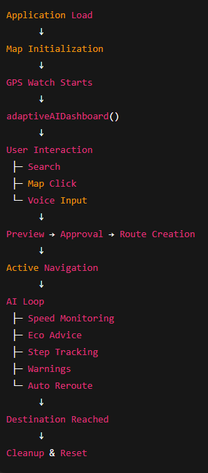

7️⃣ WHY THIS DESIGN IS CORRECT
✔ Location-first (not instruction-first)
✔ Prevents step mismatch
✔ API-safe (rate-limited)
✔ Works offline partially
✔ Scalable for future AI models
✔ Clean separation of concerns

